Daphne Stephenson Designs
The fashion range comprises: kaftan, kimono, dressing gown, cape, pantaloons, silk scarves, tote bag, cushion and notebook
Fashion and accessories
Kaftan – from £375 | Kimono – from £185 | Dressing gown – from £185
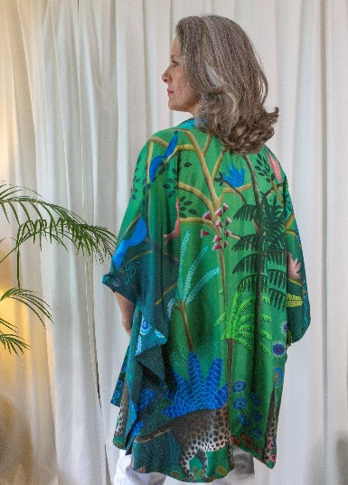 | 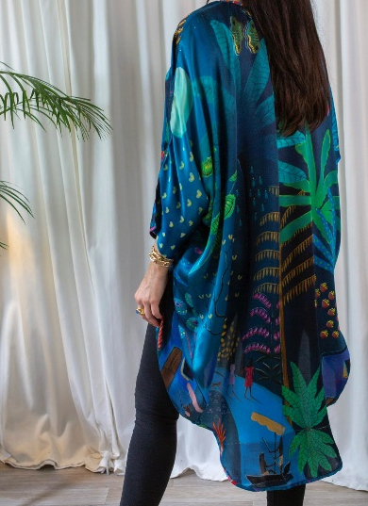 | 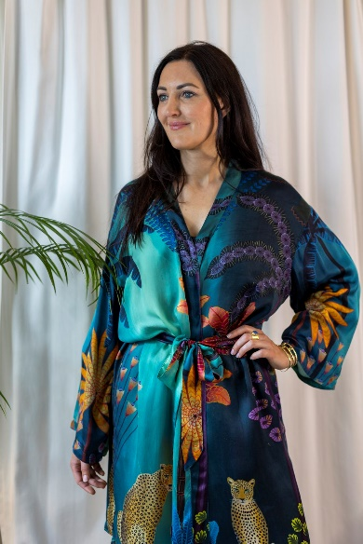
Cape – £175 | Pantaloons – £150 | Silk scarf (long) – £175
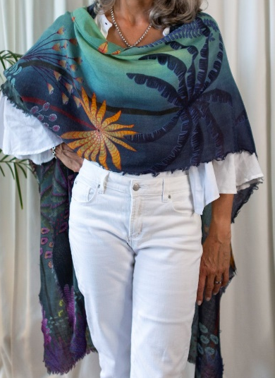 | 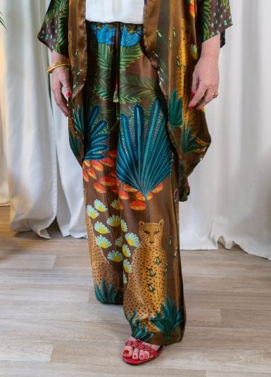

Fashion and accessories (cont’d)
Silk scarf (square) – from £185 | Tote bag – from £70 | Cushion – from £70
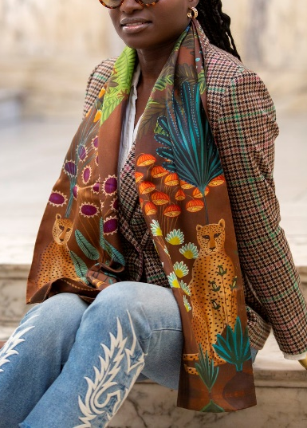 | 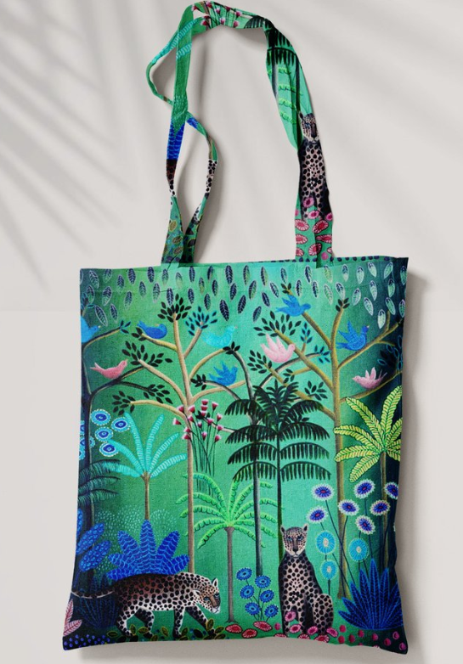 | 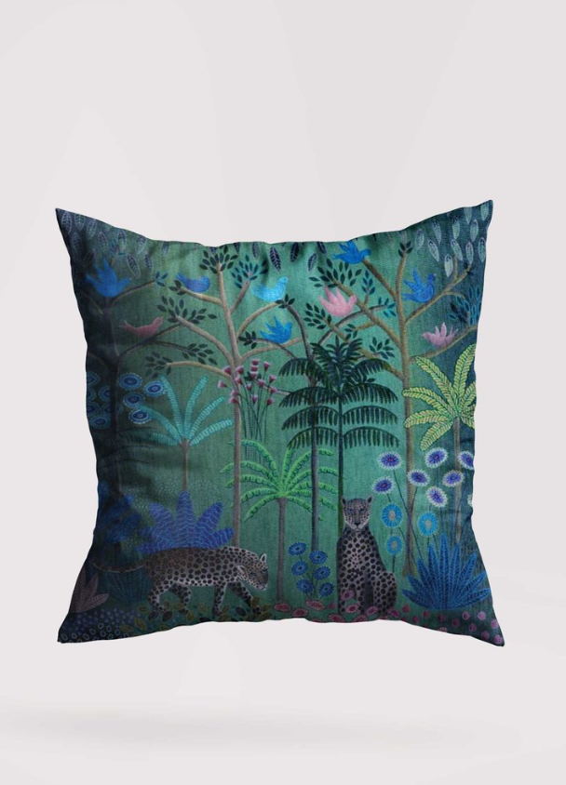  and more…

Designs
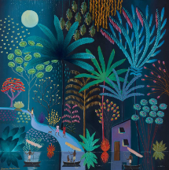 | 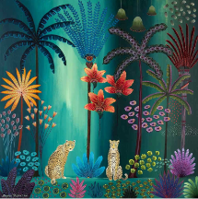 | 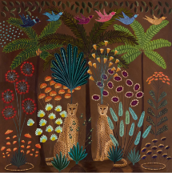
Moonlight walk | Twilight jungle paradise | Two of a kind
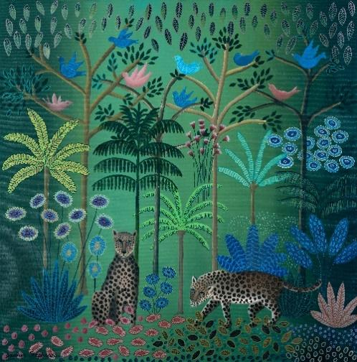 | 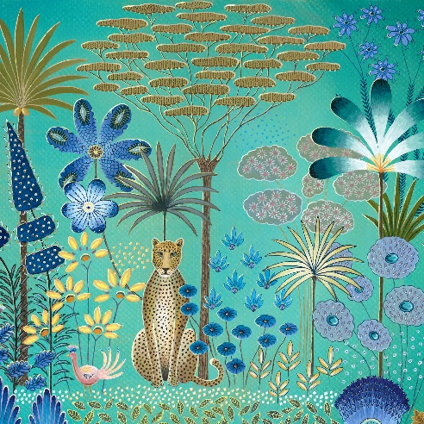 | 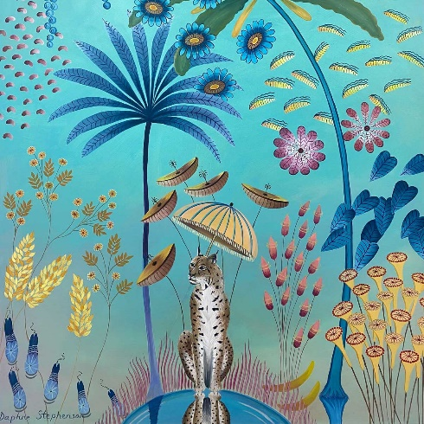
You have been up to no good again | Leopard in moonlight | Reflections of a lynx
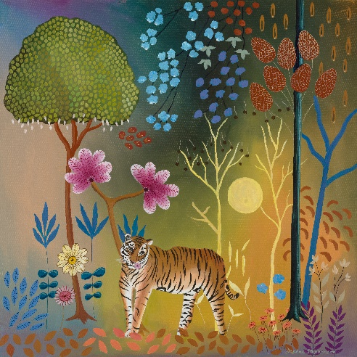 | 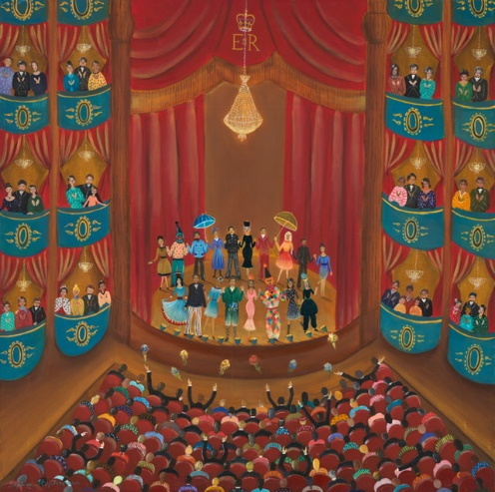 | 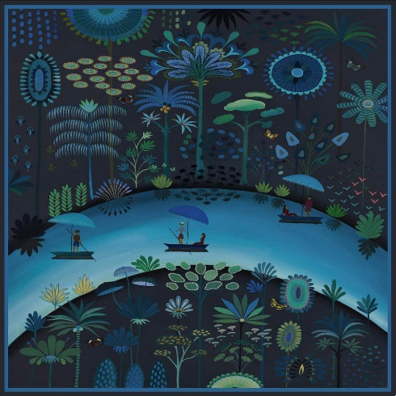
Reflections of a tiger ^ | Standing ovation ^ | Row your boat ^
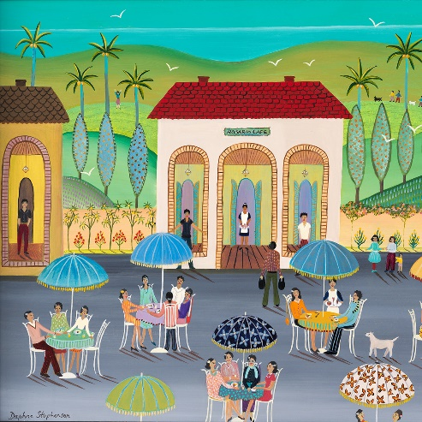 | 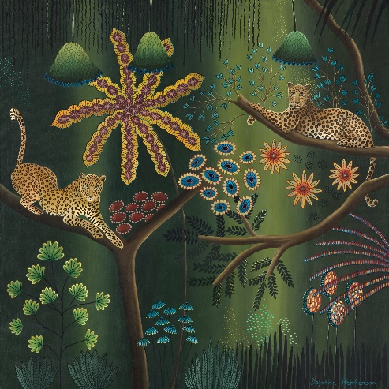 | 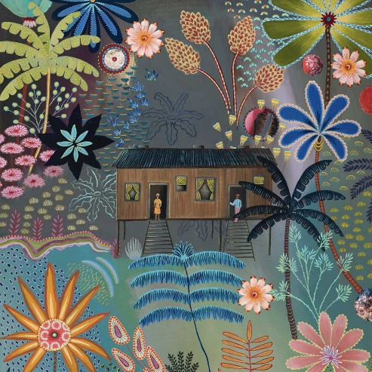
Rosario café ^ | Jungle harmony ^ | Jungle flowers ^
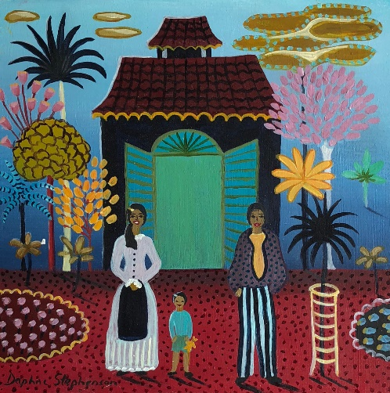 | 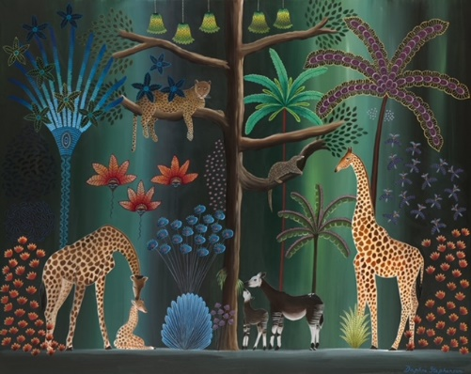
Happy home ^ | Garden of Eden | and more…

^Available in limited edition Prints, Scarves and Greeting Cards

Daphne Stephenson Art and Designs
Phone 07709 431 680 | Email daphnestephenson@aol.com
Website (Art) Daphne-Stephenson.com| Website (Designs) DaphneStephensonShop.com

