For Immediate Release
25th October 2023

Award-Winning Artist Launches Exotic Fine Art Prints on Luxury Fabrics
Stunning Fashion Range Perfect For Leopard Print Addicts Everywhere

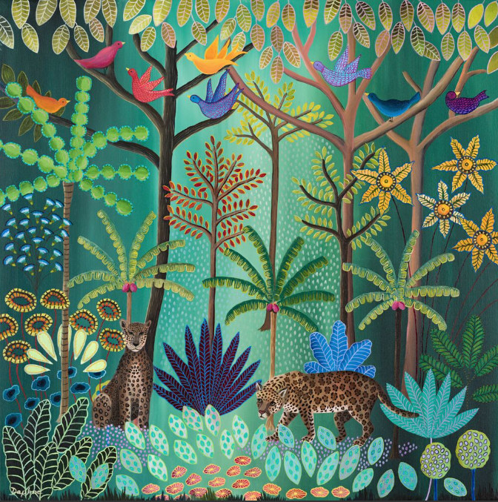

Daphne Stephenson, renowned for her Primitive-Naive style of Art where she paints energising and uplifting Exotic Jungle scenes with mesmerising eyes and expressions, is launching her first fashion collection on 9th November at the Kelling Design Showroom, SW10.
She is making her stunning collectors art available to be worn and the results have been better than she had hoped for. Walking down the Kings Road wearing her flowing matching pantaloon, tote bag and silk scarf, she was stopped five times and asked where her bright and bold clothing came from.

“Daphne’s bold choice of colour is reminiscent of Hermes. Likewise, her Rousseau-esque finely detailed Jungle paintings are complimented by their intriguing subject matter of fantastical trees and flowers, prowling leopards and chirpy birds. She has chosen to transpose the unique subject matter of her paintings from canvas onto silk and other materials. Her stunning silk kimonos with their bold quirky designs are effectively walking pieces of art.” Val Barnes June 2023

Stephenson’s showstopping and jaw dropping exotic art (as one happy customer called it) has been transformed into moving merchandise bringing colour and life back, with a reminder and concern for the protection of wildlife, which is a cause close to her heart.
She has an abundance of experience in the Art and Design world having worked for numerous well-established companies like being In-house Designer for Halcyon Days, before launching out on her own as a solo artist 20 years ago.

She has exhibited at ING Bank in the City, The Royal Academy, Agora Gallery in New York, Masterworks Museum in Bermuda and numerous other galleries with her largest collection of 14 paintings hanging in Lyford Cay, The Bahamas, owned by Debby Brice from the original Lehman Brother family. Her work has been bought by other bankers and Royal Families in Britain and Holland.

To celebrate the official launch of the fashion merchandise collection, a launch event will be hosted at Kelling Design with details below:
Preview Night & Launch Event
9th November (6pm-9pm) Thursday &
10th November (12pm-5pm) Friday
Kelling Design Showroom, 3 Langton Street, SW10 0JL

See her full range of prints here: https://www.daphne-stephenson.com/limited-edition-prints/
Collection
You have been up to no good again
2023
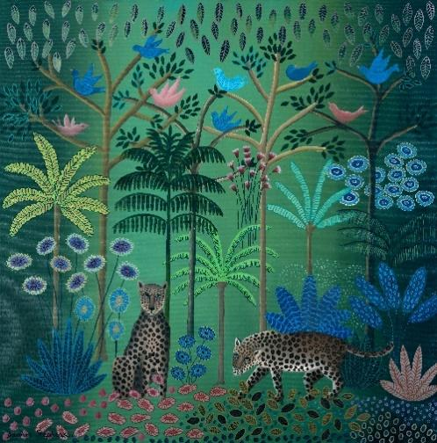
Limited Edition Signed Prints
110 x 110cm £950

The fashion range comprises: kaftan, kimono, dressing gown, pantaloons, silk scarves, tote bag, cushion and notebook
Fashion and accessories range

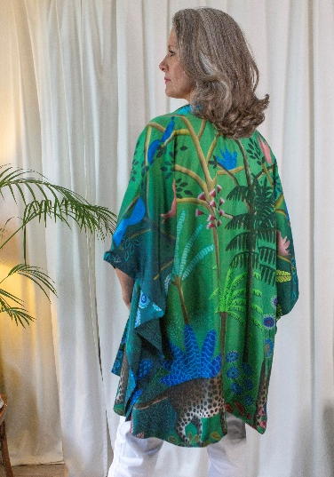
Luxury Collection
Kaftan £450
Twill double sided silk
https://www.daphnestephensonshop.com/luxury-collection/p/you-have-been-up-to-no-good-again-silk-kaftan
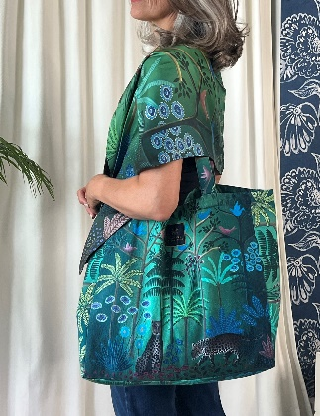
Silk Scarf (long) £175
https://www.daphnestephensonshop.com/luxury-collection
Tote Bag from £70
Made from thick cotton twill and lined inside with a zip pocket and magnet fastener
https://www.daphnestephensonshop.com/mid-range-collection/p/tote-1

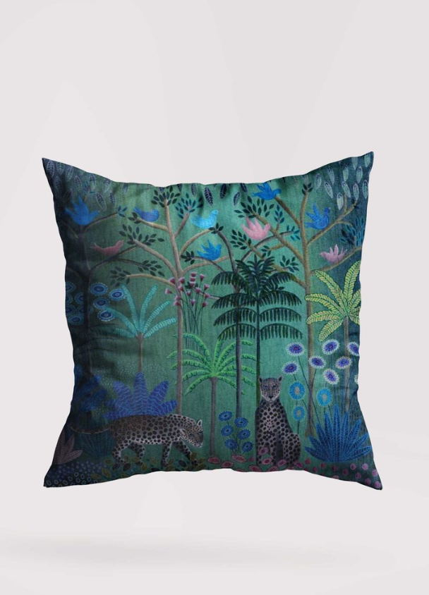
Cushion £70
Size: 51cm x 51cm
Made with top quality linen and velvet piping
https://www.daphnestephensonshop.com/mid-range-collection/p/cushion-2

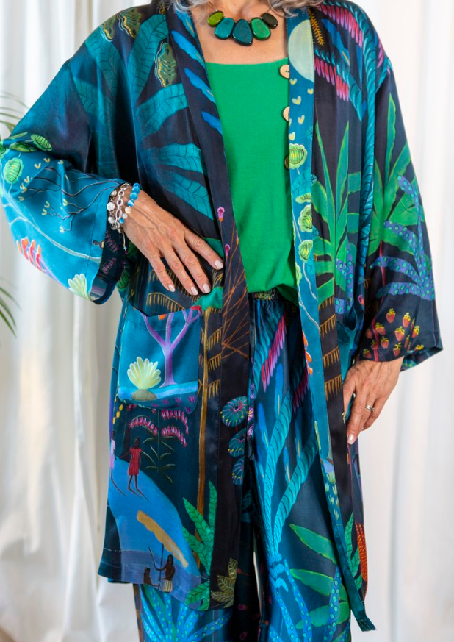

Collection: Moonlight Walk
Dressing gown £175
Modal satin
https://www.daphnestephensonshop.com/mid-range-collection/p/moonlight-walk-merino-wool-cape-wregh-yllx8

-ENDS-
MEDIA CONTACT:
Daphne Stephenson Art and Designs

Phone 07709 431 680 | Email daphnestephenson@aol.com
Website (Art) Daphne-Stephenson.com| Website (Designs) DaphneStephensonShop.com

Daphne Stephenson Art, paintings, prints and cards, was founded in 2011.
Daphne Stephenson Designs, a brand for fashion merchandise, was founded in 2023.

